Fundamentals of Data Base
Assignment 3
FAROOQ AHMAD
17L4407
BEE-8A

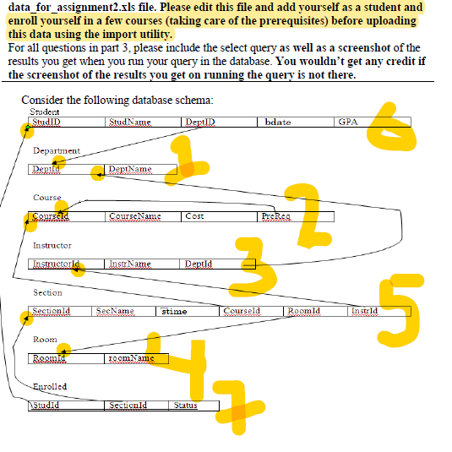

1. [CLO-2] Give SQL(DDL) statements to create the above schema in the database (in order). Please ensure that for “status” column of “Enrolled” table there should only be two possible values of “Completed” and “Enrolled.

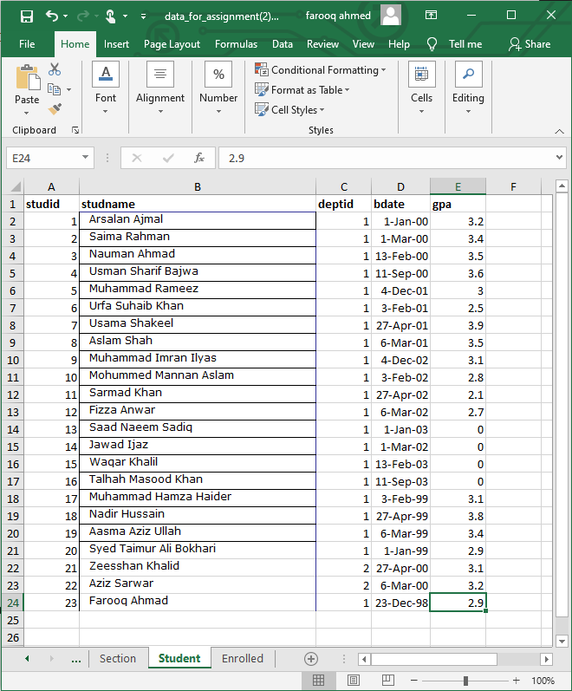
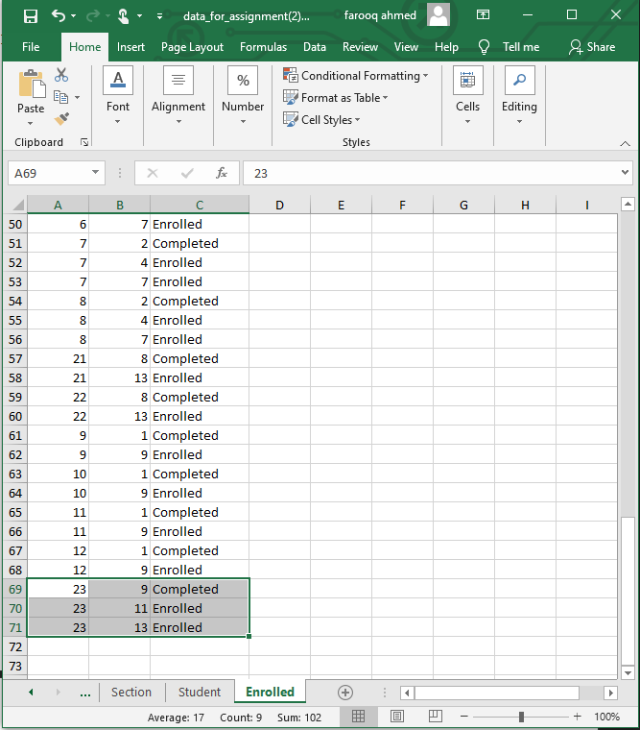
create table Student
(
StudID int primary key,
StudName varchar(40),
DeptID int,
bdate date,
GPA float,
)

create table Department
(
DeptId int primary key,
DeptName varchar(25),
)

create table Course
(
CourseId int primary key,
CourseName varchar(30),
Cost int,
PreReq int,
)

create table instructor
(
InstructorId int primary key,
InstrName varchar(25),
DeptId int,
)

create table Section
(
SectionId int primary key,
SecName varchar(20),
stime time,
CourseId int,
RoomId int,
InstrId int,
)

create table Room
(
RoomId int primary key,
roomName varchar(20),
)
create table Enrolled
(
StudId int not null,
SectionId int not null,
Status varchar(20) not null,
Primary key(StudId,SectionId,Status),
)
alter table Student add constraint dfk foreign key(DeptID) references Department (DeptId)
alter table Course add constraint pfk foreign key(PreReq) references Course (CourseId)
alter table Instructor add constraint dpfk foreign key(DeptId) references Department (DeptId)
alter table Section add constraint cfk foreign key(CourseId) references Course (CourseId)
alter table Section add constraint ifk foreign key(InstrId) references Instructor (InstructorId)
alter table Section add constraint rfk foreign key(RoomId) references Room (RoomId)
alter table Enrolled add constraint sfk foreign key(StudId) references Student (StudID)
alter table Enrolled add constraint scfk foreign key(SectionId) references Section (SectionId)
select * from Student
select * from Department
select * from Course
select * from instructor
select * from Section
select * from Room
select * from Enrolled
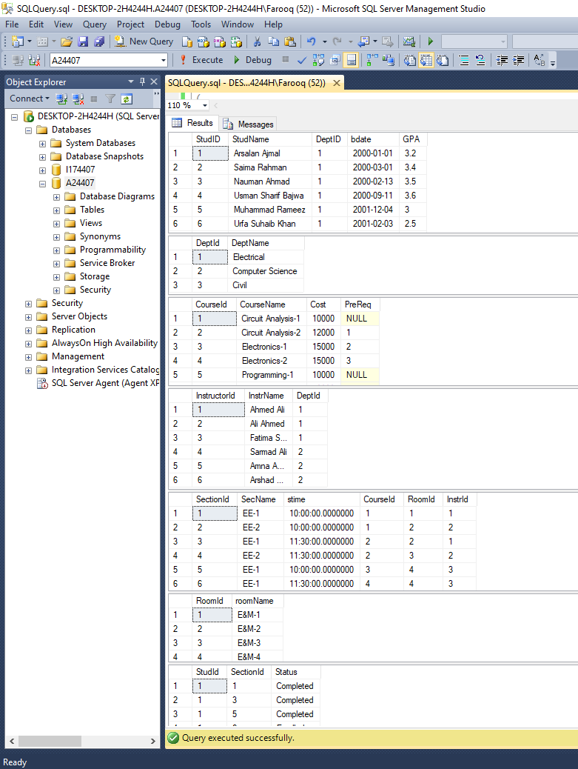

2. [CLO-3] Please mention the order in which you uploaded the data in the accompanied file into the tables created in part. Please don’t forget to add yourself as a student and ensure that all the data is correctly loaded before proceeding with part 3.

Order followed is
- Department
- Course
- Instructor
- Room
- Section
- Student
- Enrolled

3. [CLO-3] Write an SQL statement to answer each of the following queries:

a) Give the names of students who are enrolled in both “Electronics-2” and “Database Systems”.
select StudName
from Student s
inner join Enrolled e on s.StudID=e.StudId
inner join Section sec on sec.SectionId=e.SectionId
inner join course c on c.CourseId=sec.CourseId
where c.CourseName like '%Electronics-2%' and e.Status='Enrolled'
intersect
select StudName
from Student s
inner join Enrolled e on s.StudID=e.StudId
inner join Section sec on sec.SectionId=e.SectionId
inner join course c on c.CourseId=sec.CourseId
where c.CourseName like '%Database Systems%' and e.Status='Enrolled'
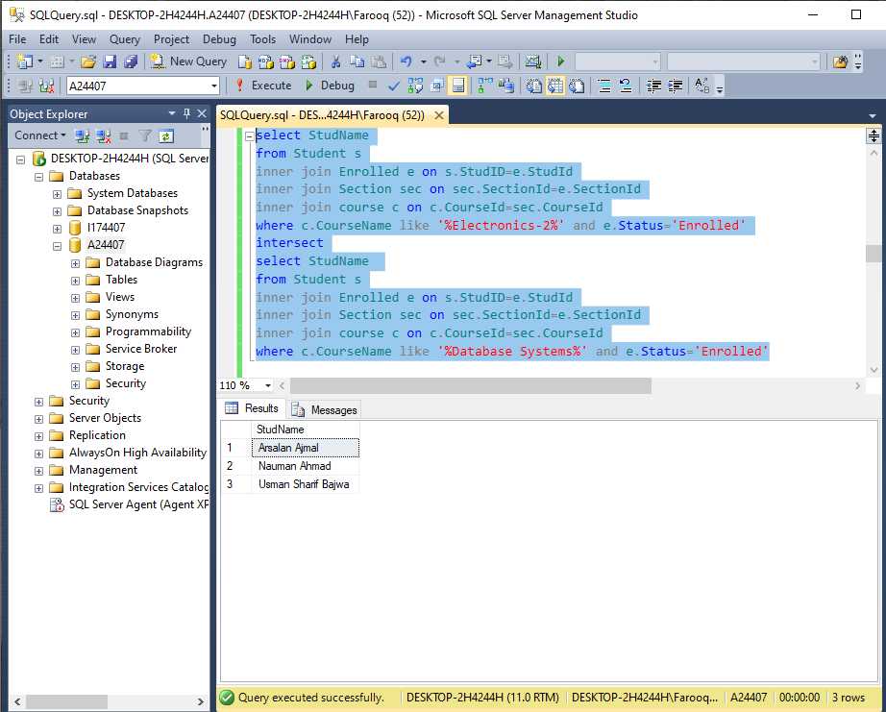

b) Give the names of sections (and the courses they belong to) which are taught in room ‘E&M-5’ or have more than 5 students enrolled in them.

select SecName from Section s
inner join Room r on r.RoomId=s.RoomId
where r.roomName like '%E&M-5%'
union
select SecName from section s
inner join Enrolled e on s.SectionId=e.SectionId
group by SecName
having count(e.SectionId) > 5

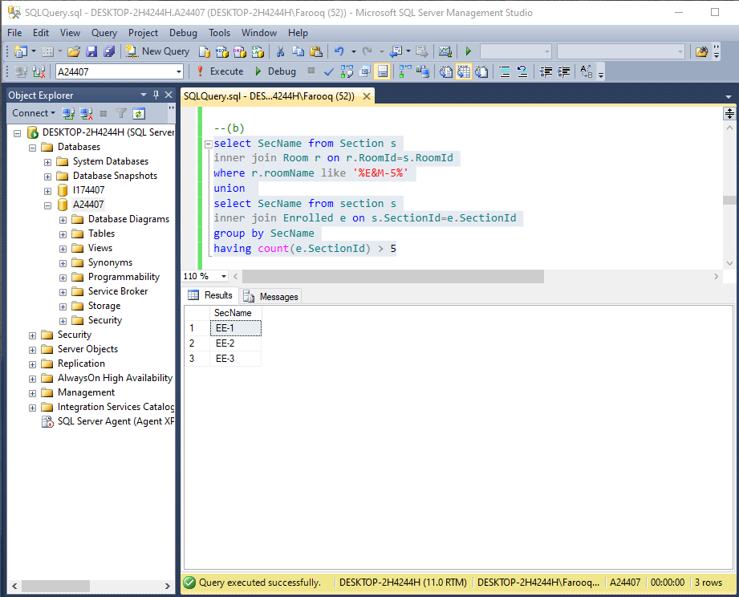

c) Give the names of students who have spent Rs50000 or more in total.
select StudName
from Student s
inner join Enrolled e on s.StudID=e.StudId
inner join Section sec on sec.SectionId=e.SectionId
inner join course c on c.CourseId=sec.CourseId
group by StudName
having sum(c.Cost) > 50000
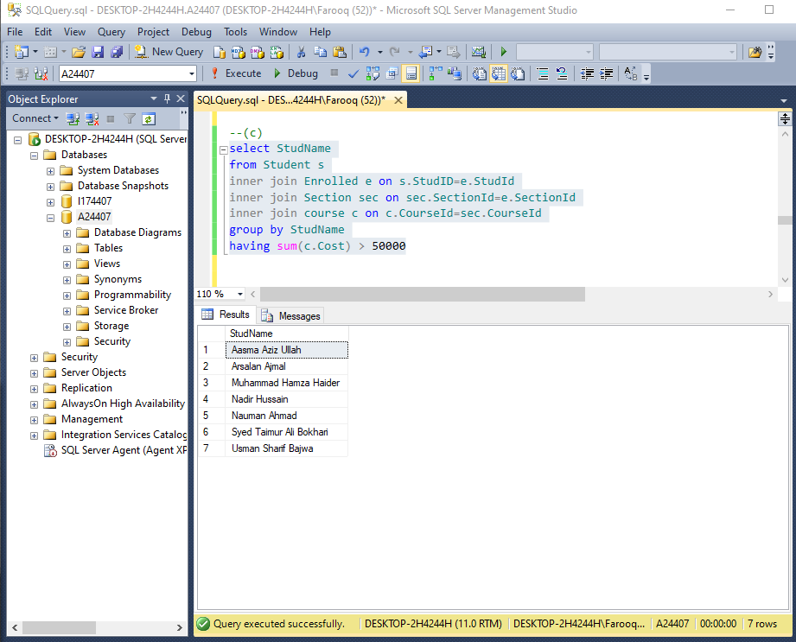

d) For every age value, find the average gpa (rounded to 2 decimal places).
select year(bdate), round(avg(gpa),2)
from student
group by year(bdate)

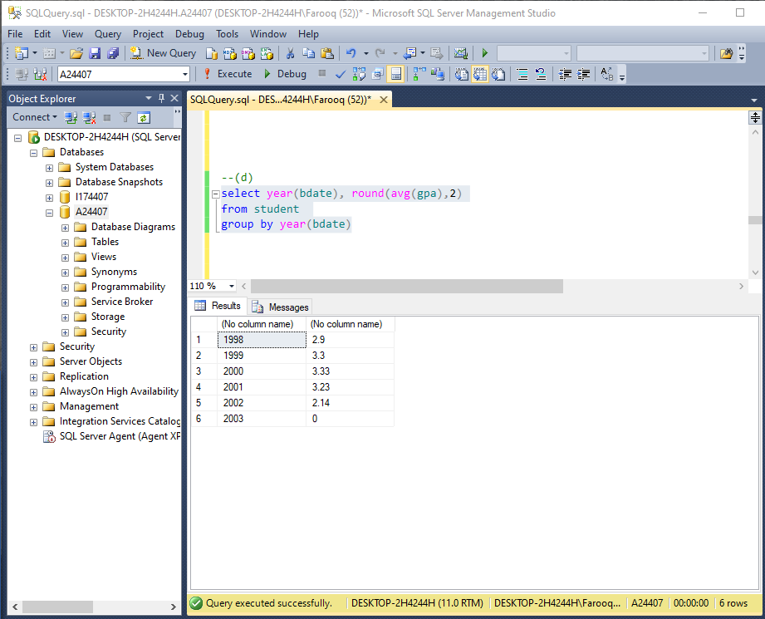

e) Find names of students who are enrolled in two (or more) sections that meet at the same time.
select s.StudName, sec.stime from student s
inner join enrolled e on s.StudID=e.StudId
inner join Section sec on sec.SectionId=e.SectionId
group by s.StudName, e.StudId,e.Status, sec.stime
having count(Sec.SectionId)>=2 and e.Status='Enrolled'

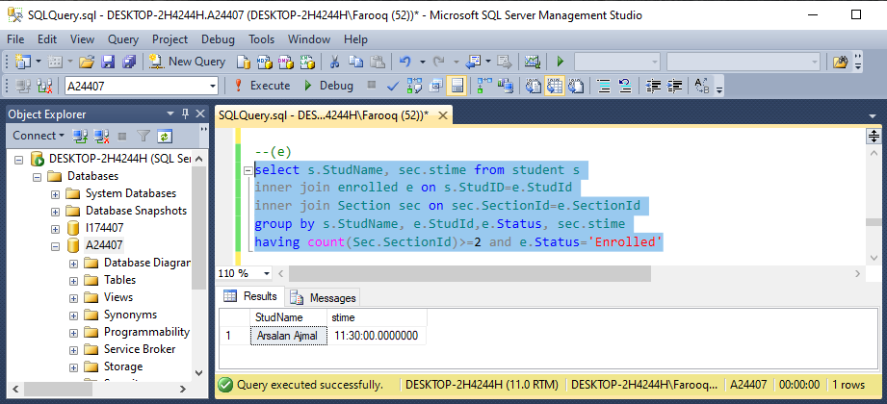

f) Find the instructor(s) who has taught in every room in which a section has been taught
select i.instrName, i.InstructorId from instructor i
where not exists
(select * from room r join section s
on r.roomid=s.roomid and r.roomid not in
(select s.roomId from section s
where s.instrid=i.instructorId))

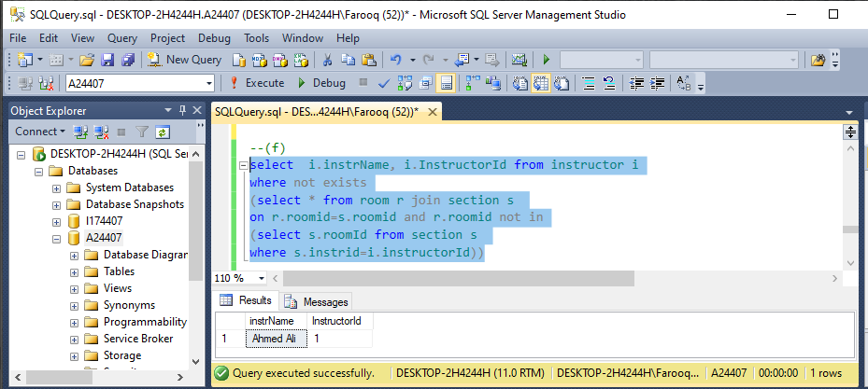

g) Find the students who are eligible to take Electronics-2 (they would have completed the prerequisite(s) and wouldn’t have yet taken Electronics-2).
select s.StudName from student s
join Enrolled e on s.StudID=e.StudId
join section sec on sec.SectionId=e.SectionId
join Course c on c.CourseId=sec.CourseId
where e.Status='completed' and c.CourseId = (select PreReq from Course
where c.CourseName like 'Electronics-2') and not exists
( select * from Enrolled e1 join Section sec1 on sec1.SectionId=e1.SectionId
join Course c1 on c1.CourseId=sec1.CourseId
where c1.CourseName='Electronics-2')

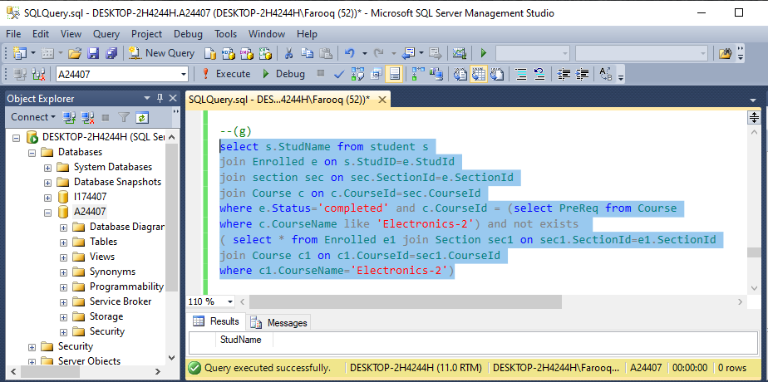

i) List all the departments together with the names of instructor who belong to them. Note the department name must appear even if it has no instructor in it.
select d.DeptName, i.InstrName
from department d
left outer join instructor i on i.deptid=d.deptid

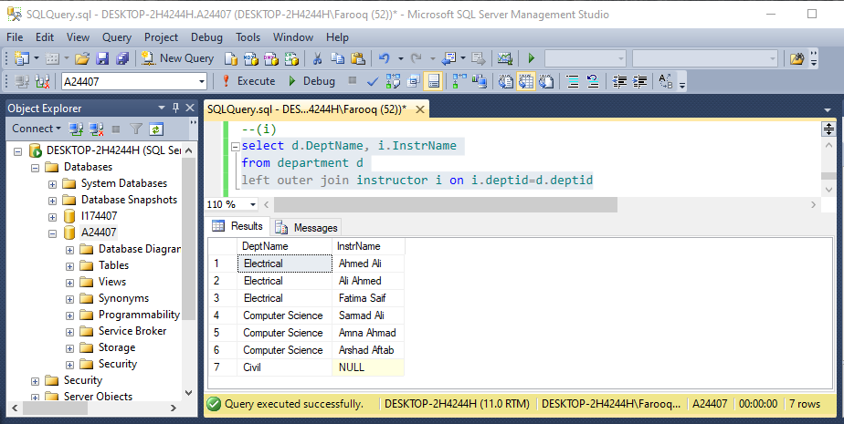

j) Find the course which has been taken by the maximum number of students, alongwith the number of students who have taken it.
select c.coursename, count(*) No_of_Students
from course c join section s on c.courseid=s.courseid
inner join enrolled e on s.sectionid=e.sectionid
group by c.coursename
having count(*)>= all (select count(*)
from course c join section s on c.courseid=s.courseid
inner join enrolled e on s.sectionid=e.sectionid
group by c.coursename)

